EE ADAS Ultrasonic Mechanical Integration

Introduction

Purpose

Comment00105316
The purpose of this specification is to provide design, packaging and body engineers the mechanical integration and positional requirements for the AAD Level 2+ & Level 3 ultrasonic sensors low speed manuevaring.

Scope

Comment00105317
This standard applies to Jaguar Land Rover (JLR) vehicles which use ultrasonic sensors for Low Speed Manoeuvring (LSM) applications.

Revision History

Comment00105318
[October 2022 / Version 1 / pgote]

Terminology

Acronyms / Abbreviations

Comment00105319
Term | Definition
ADAS | Advanced Driver Assistance Systems
CoC | Centre of Competence
DCR | Decoupling Ring
DODS | Door Object Detection System
DVA | Dimensional Variation Analysis
ECU | Electronic Control Unit
FOV | Field of view
JLR | Jaguar Land Rover
LSM | Low Speed Manoeuvring
PCB | Printed Circuit Board
USS | Ultrasonic Sensor

Definitions

Comment00359140
the sensor's 180º Field of View refers to the semisphere centered at the sensor's membrane that would represent the FoV of the sensor if the sensor's FoV was 180º for the Vertical and Horizontal directions.
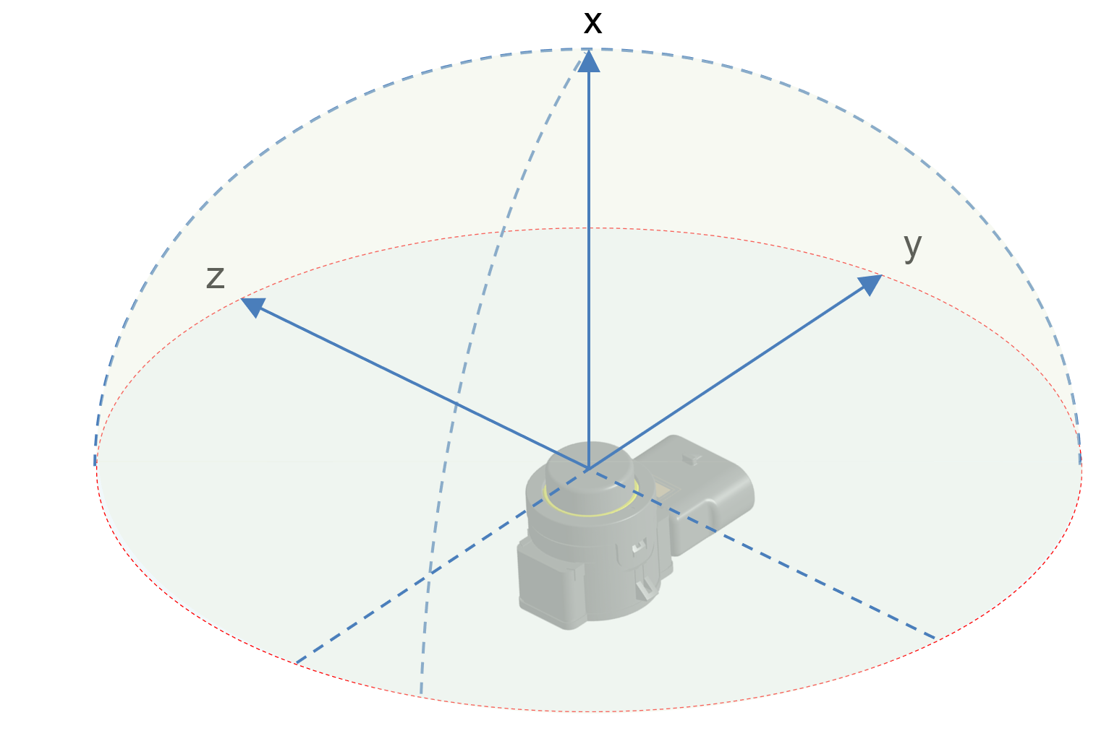

Requirements

Positional Overview

Comment00110751
The positional overview of Ultrasonic sensors for low speed manoeuvring (LSM) is shown below.
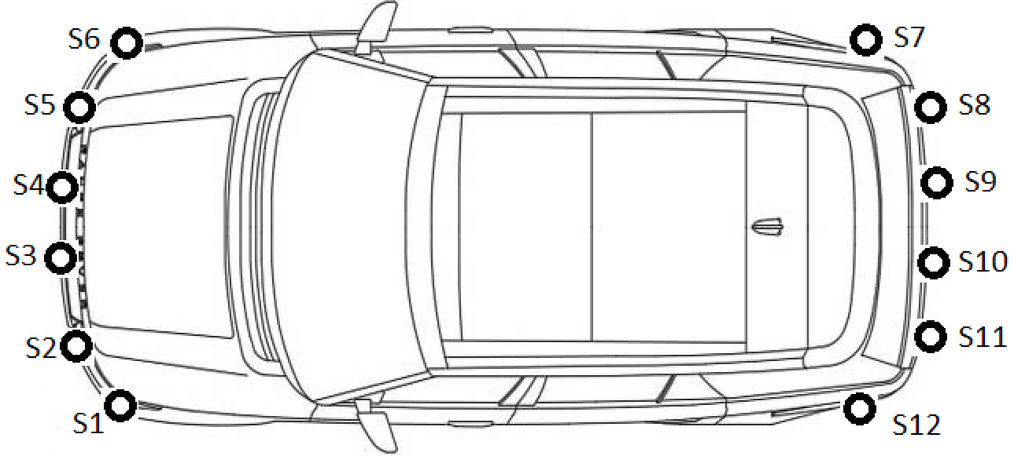

Integration Requirements

Sensor Position

Vehicle Level

Dimensional parameters - vehicle level
The dimensional variation analysis shall be performed for the dimensional parameters of the sensors such as Z position and beta angle with respect to vehicle co-ordinate system.

Beta angle - vehicle level
Vertical angles between the sensor and the ground plane (β-angle) shall be in the range of +/- 3º with respect to nominal value considering vehicle co-ordinate system.

The Z position tolerance - vehicle level
The Z position tolerance of the sensor shall be equal to ± 5 mm with respect to nominal value considering vehicle co-ordinate system

Sensor Level

USS axis system
USS axis system
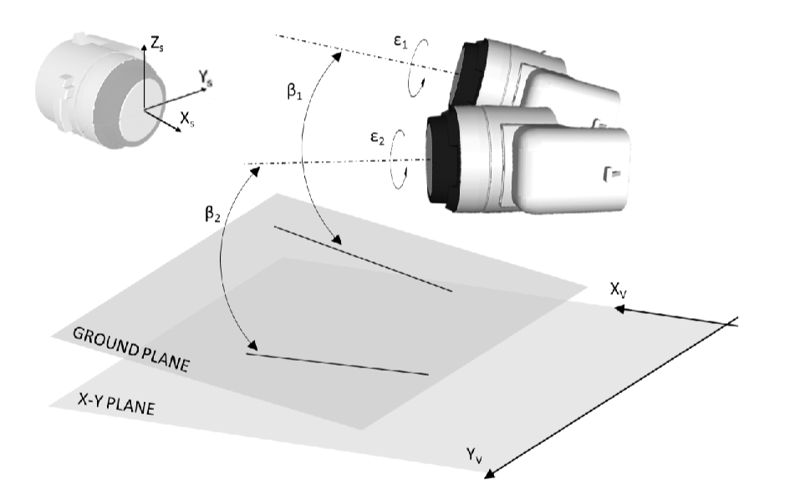

Dimensional parameters - sensor level
The dimensional variation analysis shall be performed for the dimensional parameters of the sensors such as X,Y,Z positions as well as alpha, beta and gamma angles with respect to sensor co-ordinate system within the bumper subsystem.

X position tolerance - sensor level
The X position tolerance of the sensor shall be equal to ± 5 mm with respect to nominal value considering sensor co-ordinate system within the bumper subsystem.

Y position tolerance - sensor level
The Y position tolerance of the sensor shall be equal to ± 5 mm with respect to nominal value considering sensor co-ordinate system within the bumper subsystem.

Z position tolerance - sensor level
The Z position tolerance of the sensor shall be equal to ± 5 mm with respect to nominal value considering sensor co-ordinate system within the bumper subsystem.

Beta angle tolerance - sensor level
The beta angle tolerance of the sensor shall be in the range of +/- 3º with respect to nominal value considering sensor co-ordinate system within the bumper subsystem.

Alpha angle tolerance - sensor level
The alpha angle tolerance of the sensor shall be in the range of +/- 2.5º with respect to nominal value considering sensor co-ordinate system within the bumper subsystem.

Epsilon angle tolerance - sensor level
The epsilon angle tolerance of the sensor shall be in the range of +/- 2º with respect to nominal value considering sensor co-ordinate system within the bumper subsystem.

Sensor Flushness and DCR

sensor flushness value
The flushness of the USS along with its tolerance shall comply with DRJLR.BP.7039 Ver02 (i.e. design rule for USS sensor integration geometry).

DCR compression
The DCR compression shall be in the range of 0.8mm to 1mm

Comment00360120
Compression shall be evenly distributed around the DCR.

Integration of Ultrasonic sensors

Comment00357012
Figure: Mechanical interfaces that affect sensor position on the vehicle.
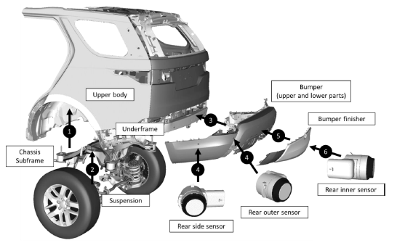
If it’s relevant for some applications, it’s recommended to locate the sensors in the upper part of the bumper, which provides better stability due to direct connection with the body. Grilles, finishers or styling features with moulded-in sensor latches, located in the upper part of the bumpers introduce less risk in overall tolerance than finishers with separate sensor holders.

Impact of bumper geometries
The ultrasonic sensor integration shall ensure that the sensor's field of view is clear of obstructions of any part of the bumper's geometry.

Requirement01024789
The ultrasonic sensor integration shall ensure that the sensor's 180º Field of View is clear of obstructions from vehicle surfaces with a slope of less than 45º with respect to the sensor's X axis.

Comment00359087
Example of non compliance with Requirement01024789: a surface with a slope of less than 45º impacts the sensor's 180º FoV
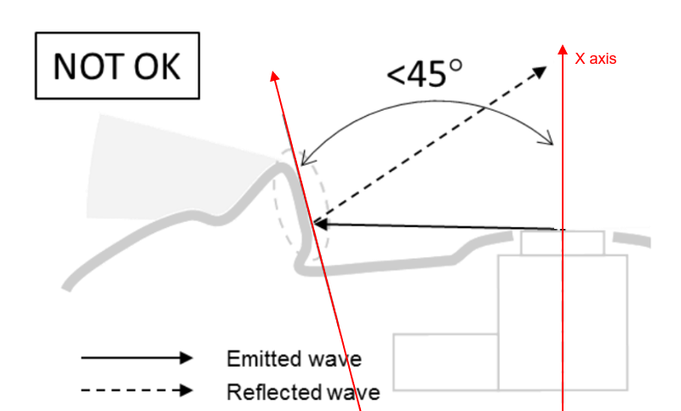

Requirement01017189
The supplier shall review the sensor position layout and bumper design provided by JLR and provide assessment on any risks identified.
NOTE: this requirement covers the need to have an early assessment from the supplier, in the role or technical expert, as a sign off for the design phase.

Comment00357237
[RQ_340] For vehicles with same wheelbase and steering geometry, a common sensor layout shall be used in order to maintain the same configuration settings required by the ECU.

Commodity strategy
Where the vehicle program includes variants that introduce modifications affecting the sensor's field of view, the ultrasonic sensor integration shall be agreed with the supplier.

Movable vehicle parts influence on sensor FOV
The ultrasonic sensor integration shall ensure that the sensor's field of view is clear of obstructions by any vehicle moving parts in the entire range of their movement.

Comment00357238
Example of "vehicle moving parts" are: Headlamp cleaners, wheels on the steering axles, doors and deployable side steps (DODS integration), active spoiler, Tailgate.

Vehicle accessories consideration
The ultrasonic sensor integration shall ensure that the sensor's field of view is clear of obstructions from any accessory listed in the accessory vigenette.
NOTE: This requirement does not apply to accessories used in the event of vehicle breakdown (in particular to towing eyes and towing ropes)

Comment00360122
Example of accesories are: towbar, winch, spare wheel cover, lamp guards, bike carriers.

Requirement01014344
The supplier shall provide asessment for any accesory or moveable part that affects the field of view, delivering a document with final statement and suggested actions.

Integration near openings and cavities
The ultrasonic sensor integration shall ensure that the sensor's 180º FoV has a clearance of minimum 3mm, in addition to the build tolerances, from any openings or cavities of the bumper.
NOTE: Any deviation to this requirement shall be agreed by the supplier.

Requirement01014360
The supplier shall provide asessment on the risks derived from any openings or cavities formed by vehicle structures that interfere with the sensors field of view within 180 degrees, delivering a document with final statement and suggested actions.

Comment00357243
Openings or cavities formed by surrounding surfaces could create conditions for multiple reflections resulting in an extended and undesired return path of ultrasonic waves. Sensor integration shall aim to eliminate known factors contributing to false detection caused by integration of sensors in such areas.
Examples: | Horizontal cross-section through installation area (front corner grille):  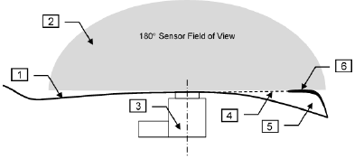  1 – Installation area, 2 – Field of view, 3 – Ultrasonic sensor, 4 – Cavity inlet,  5 – Cavity formed by exterior trim, 6 – Styling feature (fin)  The sensor field of view in the above example is not obscured, but it is just in contact (4) with cavity (5) formed by styling feature (6). This represents a potential risk of false detections.

Examples: | Surface deformation caused by temperature could result in ultrasonic waves finding their way into the cavity resulting in undesired echo path and false detection:  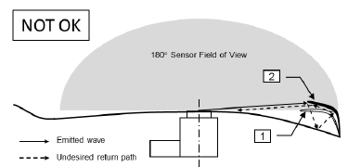  1 – Intended surface geometry, 2 – Surface deformed by temperature (overdrawn)  Hence additional clearance has to be maintained:  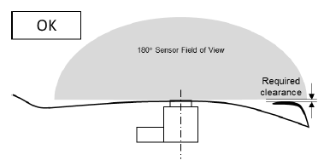

Vicinity of hot air sources

Description
The purpose of this requirement is to eliminate known factors contributing to false detection caused by refraction. Refraction is a phenomenon taking place when a wave passes from one medium to another, resulting in a change of its direction. It also applies to ultrasonic waves traveling across a boundary created by cold and hot air areas.
NOTE: General guidelines contained herein help to minimize the risk of unwanted reflections, but are not exhaustive due to the nature of the phenomenon. Additional tests on representative vehicles are recommended.

Rear exhaust pipe

Description
Reflections from exhaust gases are likely to happen if they accumulate in the field of view of the sensors. Contributing factors are windless weather, vehicle not moving or slow backward driving.

Minimum distance of the sensor
Requirements: | [RQ_330] Sensors shall be positioned in such a way, that their membranes are located outside of the area (zone “A” – see example) limited by a closed curve imagined on the surface of the vehicle, where each of the curve’s points is distant from the outer end of the exhaust pipe opening by minimum 100 mm.  These areas shall be determined for each exhaust pipe on the vehicle.  If the end of the exhaust pipe opening is covered by the tailpipe finisher, the above requirements apply to a geometry of the opening it creates (subject to ADAS assessment).
Examples: | Example tailpipe finisher:  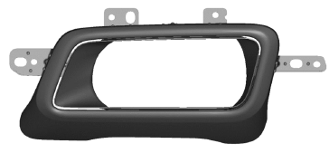

Examples: | Sensor positions subject to restrictions due to exhaust pipe proximity:  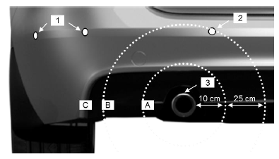  Example for a rectangular-shaped exhaust pipe:  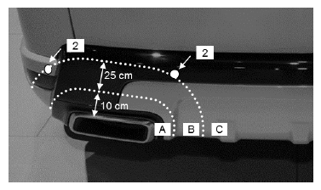  1 – Sensors located in the unrestricted area (zone “C”), 2 – Sensors located in the moderate area(zone “B”) where additional conditions apply, 3 – Outer end of exhaust pipe opening used to define the forbidden area for sensor integration (zone “A”)

Sensor direction relative to exhaust pipe
Requirements: | [RQ_331] For sensors located in the moderated area (zone “B” as shown in example) impact of hot air can be minimized by changing sensor angle relative to exhaust outlet axis.  This can be achieved by providing difference in angles of a minimum 15 degrees between sensor membrane and the exhaust outlet axis, measured on an X-Y plane in the vehicle’s coordinate system.  Appropriate surface study shall be part of iteration loops with Design and relevant CoC’s.
Examples: | Different zones near exhaust pipe.  Examples below show a plan view of a vehicle and apply to sensors located in zone “B”.  Difference in angles between exhaust pipe and sensor axes prevents direct reflections back to the sensor:  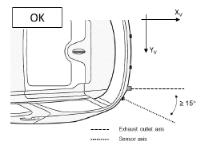  If the difference in angles is too small, reflections from exhaust gases are more likely to happen:  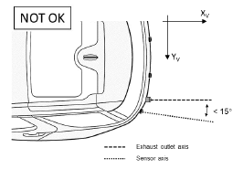
-

Front grille and air intakes

Description
Hot air pushed out of the engine compartment through the front grilles or air intakes produces hot air accumulation in the bumper vicinity. This may lead to unwanted reflections of ultrasonic waves and change their propagation path. This is particularly important if the correct system integration was achieved by use of near field filters or similar feature, which minimizes the influence of the vehicle’s own geometry on the echo received by the sensors.

Positioning in heat sources vicinity
The ultrasonic sensor integration shall ensure that the sensor is placed in a volume where the air temperature is kept below 95ºC while in operation.

Comment00357013
Impact of hot air should be minimized. Alternative sensor positions or other means of keeping them away from heat sources should be considered.
Requirement: | The following shall be considered, when positioning sensors in the vicinity of heat sources:  [RQ_332] The impact of hot air accumulation in the vicinity of sensors shall be assessed by sensor supplier.  The position of engine radiator, presence of grille shutters (active vanes) and related subsequent changes in their layout shall be assessed by the sensor supplier for any impact on the echo received by the sensors.  This requirement also applies to other heat exchangers which may adversely affect the conditions sensors have been calibrated to.
Examples: | Reflections from hot air coming out of the engine compartment:  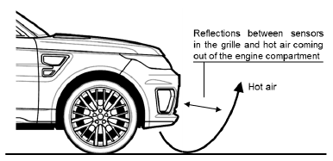

Vehicle Zones

Comment00321943
The USS sensor can be considered under the following package zone (as defined in STJLR.00.5164):
Sensor | Package Zone  (STJLR.00.5164) | T_max (°C)  (JLR-HTG-559630) | T_cont (°C)  (JLR-HTG-559630) | Applicability
USS Front S1 | B4 | 70 | 70 | Soft-top, Sedan, Estate, SUV
USS Front S2 | B4 | 70 | 70 | Soft-top, Sedan, Estate, SUV
USS Front S3 | B4 | 70 | 70 | Soft-top, Sedan, Estate, SUV
USS Front S4 | B4 | 70 | 70 | Soft-top, Sedan, Estate, SUV
USS Front S5 | B4 | 70 | 70 | Soft-top, Sedan, Estate, SUV
USS Front S6 | B4 | 70 | 70 | Soft-top, Sedan, Estate, SUV
USS Rear S7 | D4 | 110 | 80 | Soft-top, Sedan, Estate, SUV
USS Rear S8 | D4 | 110 | 80 | Soft-top, Sedan, Estate, SUV
USS Rear S9 | D4 | 110 | 80 | Soft-top, Sedan, Estate, SUV
USS Rear S10 | D4 | 110 | 80 | Soft-top, Sedan, Estate, SUV
USS Rear S11 | D4 | 110 | 80 | Soft-top, Sedan, Estate, SUV
USS Rear S12 | D4 | 110 | 80 | Soft-top, Sedan, Estate, SUV

Mechanical design

Sensor holder

Water management

Water drainage
Water drainage is necessary to ensure proper operation of sensors. Residual water has a tendency to flow upward in narrow gaps due to capillary action. This may cause unwanted coupling between the sensor housing and its membrane. When water residues freeze and expand, additional pressure on the sensor housing may be generated resulting in sensor deactivation or false detections.
Examples: | Illustration of capillary action - narrowest tube draws a liquid column higher than wider tubes:  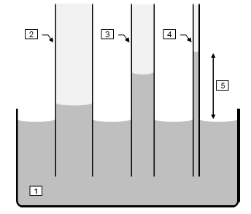  1 – Vessel of water, 2, 3, 4 – Tubes of different diameter, 5 – Observed variation of liquid level

Examples: | The example below shows the geometry in the DCR area of the sensor that promotes capillary action of water due to a narrow gap between the DCR and the sensor housing. Such a condition represents a risk of unwanted couplings (through water medium) between sensor housing and its membrane and shall be avoided:  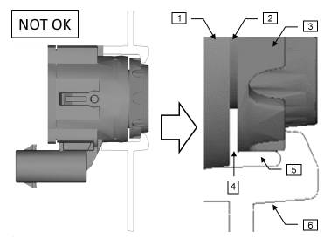  1 – Sensor housing, 2 – Sensor membrane, 3 – DCR, 4 – Narrow gap created by insufficient compression of DCR against sensor housing (overdrawn), 5 - Area where water can accumulate, 6 - Sensor holder  Correct layout of DCR and its compression against sensor housing eliminates the risk of undesired couplings caused by water residues:  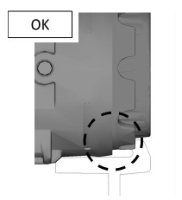

Sensor integration with holder
The holder design and sensor integration shall guarantee no gap condition between the sensor housing and the DCR in the range of expected tolerances.

Drainage hole location
The sensor holder shall comprise an aperture, which prevents water accumulation and ensures it can freely drain away from DCR area.

Comment00361985
The drainage aperture shall be as close as possible to the decopling ring.
This location is convenient to evacuate water that may accumulate in the DCR vicinity after situations like a pressure wash.

Drainage hole
The geometry of the drainage hole shall create a cut perpendicular to the ground plane of the vehicle and large enough to fully fit a square with a side of:
[shall] minimum 4 mm (including tolerances)
[Desirable] 5 mm (including tolerances)

Drainage hole clearance
The area under the drainage hole shall provide a clearance of: minimum 5 mm
Required due to possible water accumulation at the sensor (despite the presence of drainage hole), caused by barriers in the form of other attachment parts. The above requirements shall be met on an assembled vehicle. Any technological limitations compromising location of drainage hole and its desired geometry for a given design concept, shall be reported by the sensor holder manufacturer followed by the sensor supplier and ADAS team assessment.

Drainage hole geometry
[RQ_413] In order to facilitate undisturbed water flow, the acceptable size of burrs around the edge of the drainage hole shall measure: less than 0.2 mm
Examples: | Correct area and geometry of drainage hole:  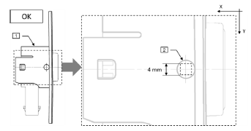  Example of too small drainage hole:  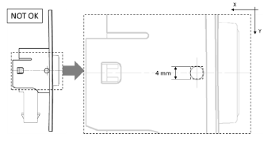  1 – Considered surface of holder, 2 – Round drainage hole fulfilling area and geometry requirements
Examples: | Exemplary shapes of drainage holes:  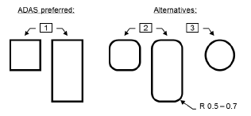  1 – Square-shaped holes, 2 – Rounded holes, 3 – Round hole

Poka-yoke features
All sensor holders shall comprise poka-yoke features or similar measures to ensure that sensor and sensor holders cannot be mis-fitted.

Sensor holder Materials

Description
This section contains materials requirements for the sensor holder and installation area and explains related limitations.

Material recommendations
The mechanical interface of the sensor to the bumper shall be made of PP material.
NOTE: The use of any other material is not allowed without previous acceptance from the supplier.

Comment00357266
According to lessons learnt with previous USS systems, the use of the following materials in the mechanical interface of the sensor shouldn't affect the sensor performance.
- PP (Daplen EE109AE)
- PBT+PC (Covestro Makroblend KU2-7912/4
- PP (sabic PPcompund 7251U)
- PP (sabic PPcompund 7536)
- PP (Hifax TKC 461X BLACK)

Comment00357258
Following materials are not recommended to use:
- Metals
- PC, PC-blends
- Unmodified PC+PBT
- ABS, ABS blends
- ASA
Hard materials or non-elastomeric modified thermoplastics such as pure amorphous plastics (like PC or PC-blends) and metallic components are not recommended for use due to their unfavourable acoustical properties

Required material properties
Selected material should have the following properties:
- Young’s modulus 1.3 GPa – 2 GPa
- Glass fibre content < 5%

Requirement00874368
The USS holder shall be attached to the bumper in the position and orientation defined in the bumper CAD design.

Process related

Description
This section contains mechanical design requirements related to manufacturing and assembly processes.

Process related
Mechanical load onto the sensor housing shall be less than or equal to 75N after completion of the assembly process.

Mechanical load on sensor membrane
No mechanical load shall be present on the sensor membranes during and after assembly process (in particular twisting or lateral force)

No damage to decoupling ring
The sensor fitment shall avoid causing any damage to the DCR (for example by burrs or sharp edges).
NOTE: fitment comprises the sensor holder, the bumper and whatever means used to attach the holder to the bumper.

Durability

Sensor holder

Sensor Retention Force
The sensor and relevant mechanical interfaces shall remain securely held within the holder when a force of 70 N < F1 < 75 N is applied for 2 seconds and 3 times as per TPJLR 18.201
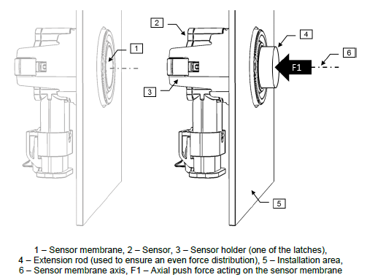

Sensor disengagement force
The sensor holder and relevant mechanical interfaces shall ensure that the sensor disengages from the holder if the axial push force is greater or equal than 75 N applied on the sensor membrane face as per TPJLR 18.201

Sensor unlatching force
The sensor and relevant mechanical interfaces shall remain securely held within the holder when a pulling force on its harness of 35 N < F2 < 45 N is applied for 2 seconds and 3 times as per TPJLR 18.201
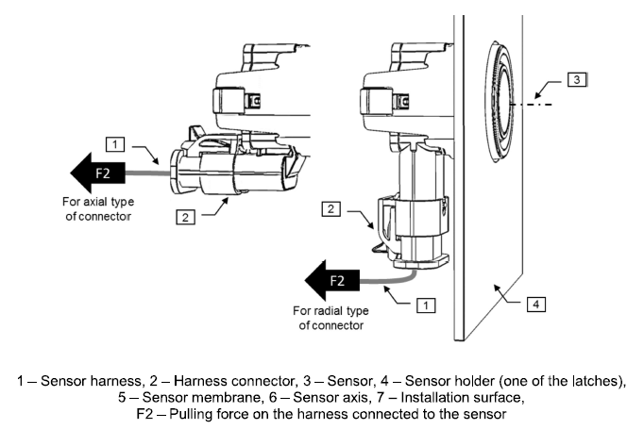

Number of insertion cycles
The sensor holder shall withstand a minimum of 5 sensor insertion and removal cycles without being damaged, losing its mechanical properties or causing damage to the sensor.
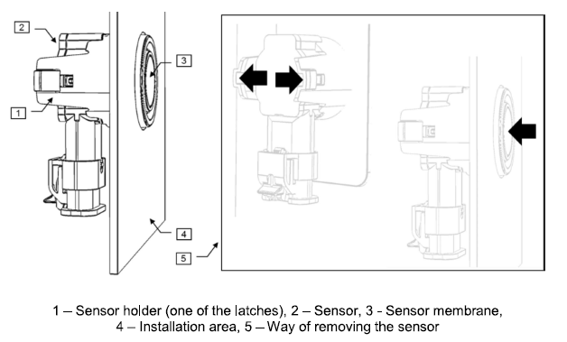

Fastening

Holder detachment force
[RQ_520] The chosen fastening method shall ensure that the sensor holder is securely attached to the installation surface upto a detaching force of greater than or equal to 150 N.
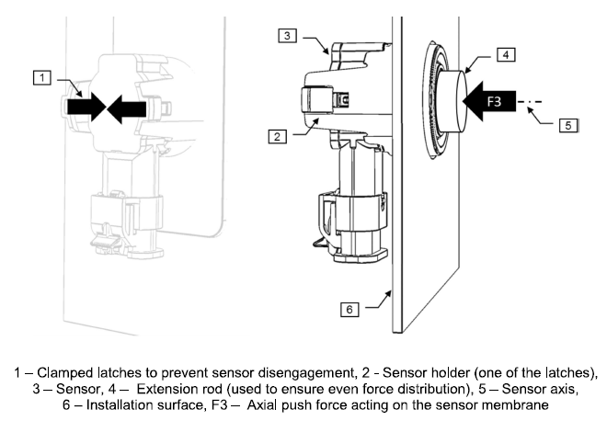

Painting Requirements

Membrane Coating
[RQ_530] The sensor membrane coating shall meet the requirements for exterior painted parts referred in STJLR.51.5241.
This requirement applies to standard coatings offered or developed by the sensor supplier or integrator (powder coating, body colour paints) and those provided by any other paint shop chosen.

Comment00358658
There are two situations where we need the supplier to deliver unpainted sensors that will be painted under the control of JLR,
- One is for those colours that are not part of the standard colour palette of the vehicle programs, or that even being part of the standard palette the expected build volumes are not enough to request the colour to be painted by the supplier, in those cases the sensors will be painted directly by JLR or by a third party.
- The other is the use in servicing as replacement sensors, these will have to be painted at the workshop to match the colour of the bumper area where it is installed.
under both situations the paint process shall comply with the following requirements.

Requirement00874366
The USS primed sensor shall be exposed to temperatures less or equal to 95ºC while painting.

Requirement00724593
The USS primed sensor shall be painted without decoupling ring​.

Requirement00724606
The USS primed sensor painting process shall prevent paint on surfaces other than the aluminium cap of the sensor​.

Comment00358857
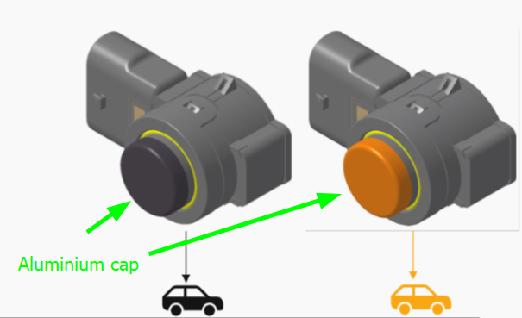

Requirement01019395
During the painting process, the axial forces to the sensor housing shall be <= 25N to avoid damage to the sensor.

Requirement00744944
The USS maximum painting thickness shall be less than or equal to 150 microns.

Requirement01041830
The paint process shall ensure that the sensor hole maintains a diameter of >= 18.0mm after bumper painting.

Standard OEM Colors Requirements

SSA Requirement00249967
The supplier shall provide painted sensors in accordance with the colour palette required by the OEM.

Requirement01024558
The painted sensors provided by the supplier shall include the following palette
 | COLOUR NAME | SOLID | METALLIC | COLOUR CODE
CORE | Fuji White (solid) | X |  | 0NER
CORE | Lovina Black (gloss) |  | X | 8PWV
CORE | Santorini Black |  | X | 8PAB
ADDITIONAL | Ostuni pearl white(gloss) |  | X | 8NCZ
ADDITIONAL | Corinthian Bronze (gloss) |  | X | 8BCF
ADDITIONAL | Charente Grey (gloss) |  | X | 8LRP
ADDITIONAL | Shifen Pearl Silver (gloss) |  | X | 8MPE
ADDITIONAL | Silicon Silver Satin |  | X | 8MFS
CONTRAST | Narvik Black (gloss)(solid) | X |  | 0PEC

Custom OEM Colors Requirements

SSA Requirement00249968
Upon completion of the RFQ process, the supplier is expected to provide unpainted sensor samples for JLR/SVO internal evaluation.

2D simulation (sensor positioning)

USS coverage layout
The ultrasonic sensor integration shall provide a coverage around the vehicle that is optimized for autonomous parking features.
NOTE: Optimal coverage is confirmed when the coverage plot is accepted by NVIDIA and the supplier.

USS coverage assessment
The supplier shall provide assessment on the simulation of the ultrasonic sensor coverage that results from the sensor poses, and provide a written statement of acceptance.

Sensor Positioning Guidelines

Front USS Positioning
The front USS Y position and alpha angle shall be packaged according to constraints defined.
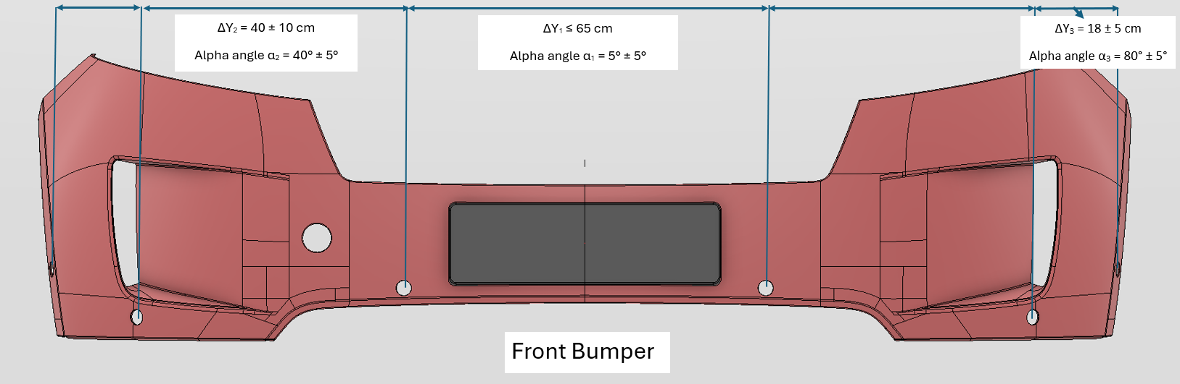

Rear USS Positioning
The rear USS Y position and alpha angle shall be packaged according to constraints defined.
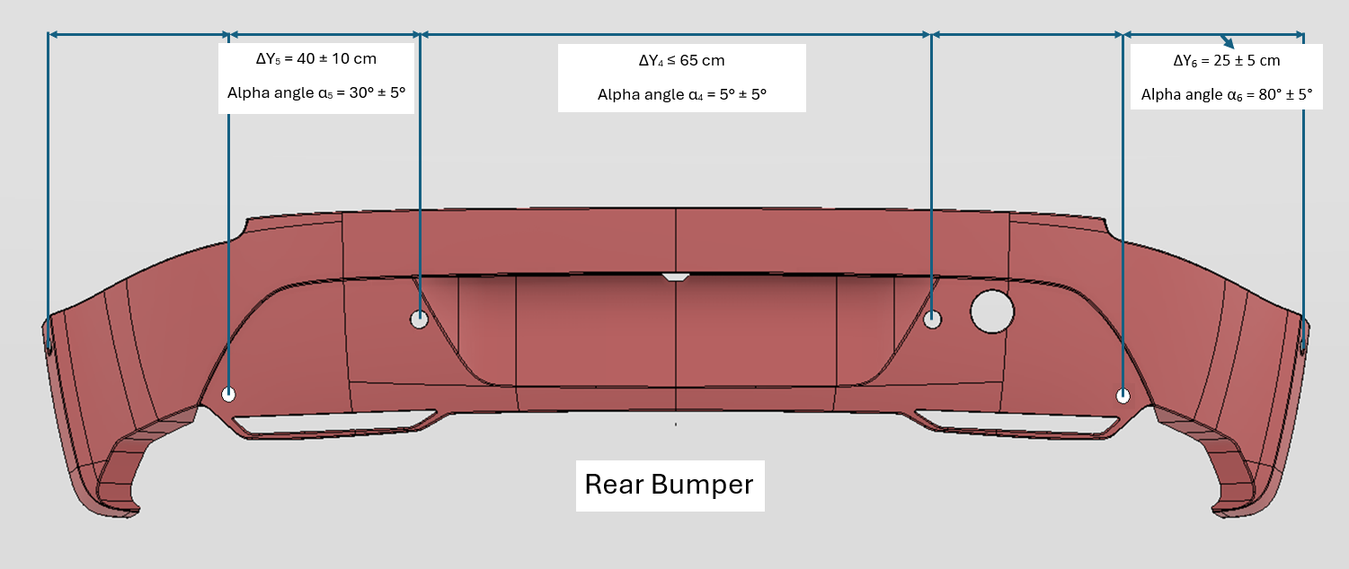

Requirement01017202
The ultrasonic sensor integration shall be done according to the Supplier Integration Guidelines.
NOTE: Any deviation from the supplier integration guidelines for USS positioning shall get the acceptance from the USS supplier.

USS positioning deviations from mounting guidelines
In case of any deviation of the final sensor positioning with respect to the supplier mounting guidelines, the supplier shall review the deviation and provide an evaluation report of the risks derived.
NOTE: final sensor position includes the tolerances.

Comment00357758
The integration guidelines provided by supplier will include a graph reflecting the allowed pitch angles for the sensor as a function of the sensor height, this is a useful tool that functional package will use to guide the discussions with the design team, however the design constraints and manufacturing tolerances will likely force the sensor to deviate under some situations from the recomended positioning. The final assessment from the supplier as technical expert is required to evaluate the possible risks of those deviations and raise the required corrective actions.
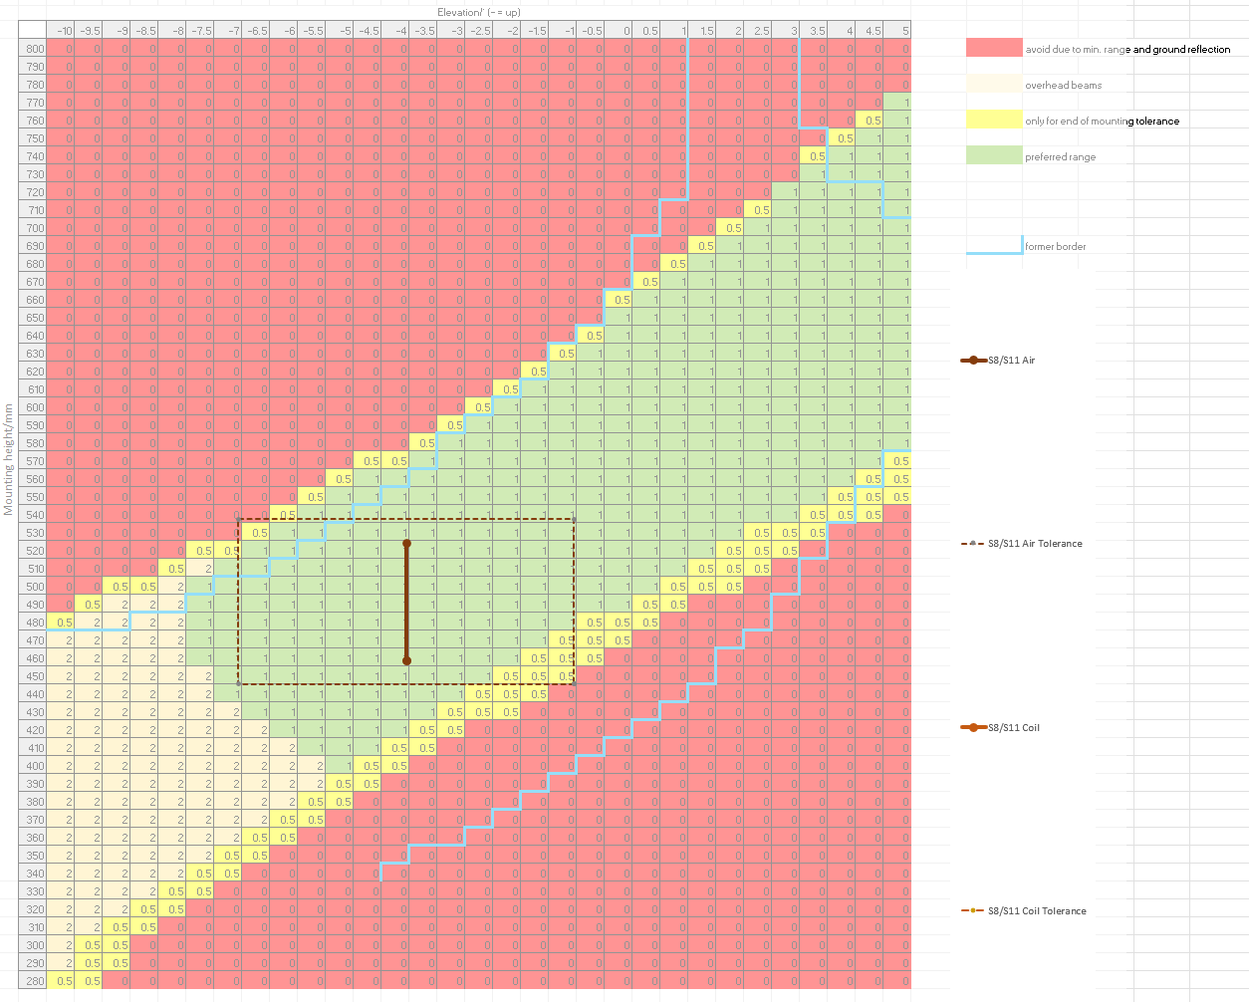

Height and beta angle based positioning
The sensor's nominal position across the whole suspension height range shall be within the green zone of the height vs beta angle graph shared by the supplier as part of the integration guidelines.

Requirement01017223
The sensor's final position across the whole suspension height range considering the manufacturing tolerances shall be within the green and yellow zones of the height vs beta angle graph shared by the supplier as part of the integration guidelines.

Requirement01017224
Any deviation that causes the sensor's final position to be in a red zone of the height vs beta angle graph shall be agreed with and accepted by the supplier.

Comment00358578
positive Beta angles will provide better detection performance in presence of ground clutter than negative beta angles,
Positive beta angles will be preferred over negative beta angles,
in terms of the graph, it is preferred to package the sensors in the left side of the green zone.

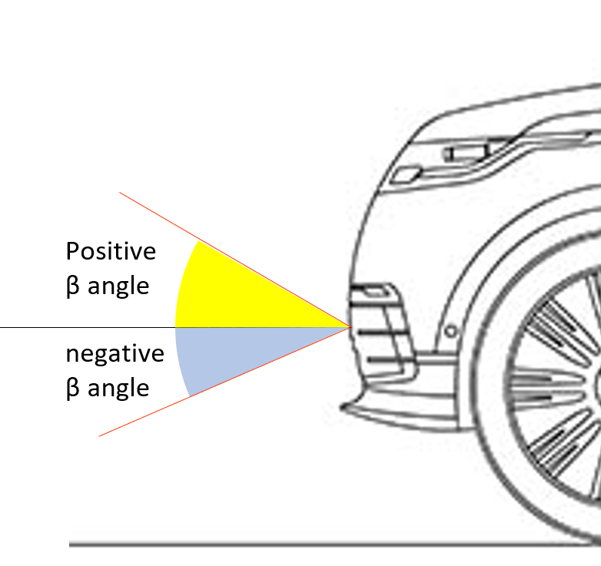

Height and beta angle assessment
The supplier shall review the relation between the final height and final beta angle and evaluate the risk derived, providing a written statement of acceptance.
NOTE: final height and final beta angle include the tolerances

USS positioning around license plate
The minimum distance of the USS(considering centre of USS membrane) particularly at position S9/S10 , S3/S4 shall be 40 mm and 60 mm from the vertical and horizontal sides of license plate respectively as shown in the figure below.
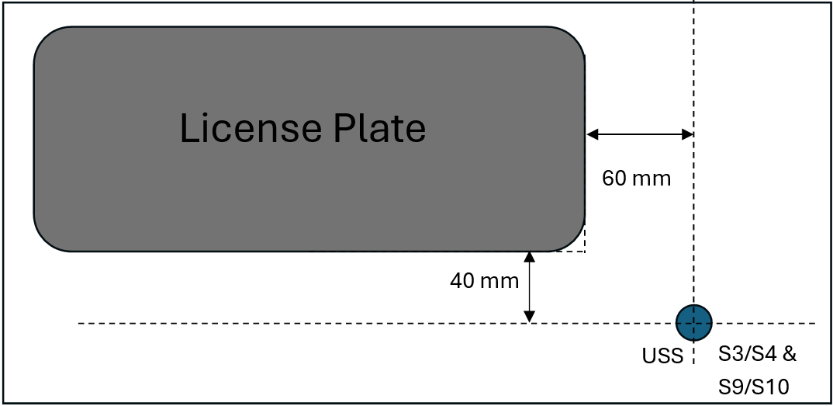

Requirement01053946
For any sensor located at 40 mm and 60 mm from the vertical and horizontal sides of license plate respectively (measured from the centre of USS membrane), the distance in the X direction from the sensor membrane to the furthest point of the license plate shall be ≤ 20 mm.
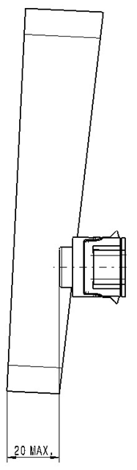

Appendix

Related Documents
TPJLR.18.201 | Integration and Packaging of Ultrasonic Sensors
STJLR.51.5241 | Performance Requirements of Exterior Painted Parts
STJLR.51.5226 | Standard Requirements For Production Materials
Following documents are listed for reference only:
BS ISO 8855:2011 | Road vehicles - Vehicle dynamics and road-holding ability - Vocabulary
BS ISO 17386:2010 | Transport information and control systems - Manoeuvring Aids for Low Speed Operation (MALSO) - Performance requirements and test procedures.
Regulation No 26 of the Economic Commission for  Europe of the United Nations (UN/ECE) | Uniform provisions concerning the approval of vehicles with regard to their external projections.

